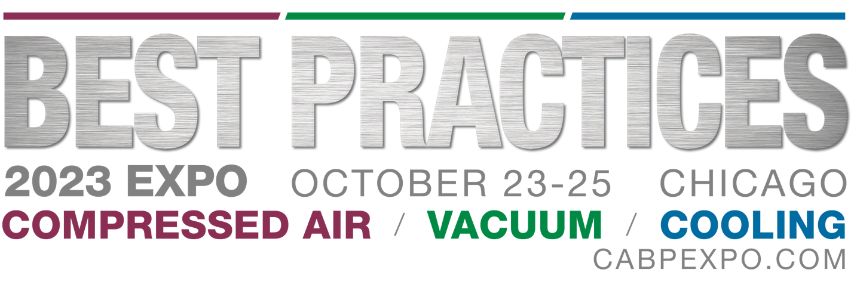
It is our mission to ensure that your participation at the 2023 Best Practices EXPO provides you with the greatest exposure for you and your business. To accomplish this, we have developed a series of tools that accompany this checklist in order to help you promote your participation in the event to your network of contacts. Follow this calendar and checklist to stretch your promotional dollars and maximize your impact at the show. Utilize our essential marketing tools, email drafts, logos, banner ads and other helpful resources.
□ Add the Best Practices EXPO logo and “See us at Booth #0000” signature to your email and encourage everyone in your business to do the same.
□ Use Best Practices EXPO logos and your booth number in company ads and marketing materials to inform current and prospective clients about your attendance at the show.
□ Incorporate social media into your Best Practices EXPO marketing plan. Use the sample social media posts provided to get started! Be sure to leverage the Compressed Air Best Practices, Chiller & Cooling Best Practices and Blower & Vacuum Best Practices LinkedIn pages by following, posting information and updates leading up to the show. Don’t forget to tag Best Practices EXPO so we can follow along!
□ Place the Best Practices EXPO banner ad on your website promoting your presence at the event.
□ Email invitations to your current customers and prospective clients. Use the Exhibitor Email Invite as a template or customize it with your unique message, including new product launches, giveaways, demonstrations and more that will be featured at your booth.
□ Look out for an email from Best Practices EXPO calling for information on your show specials & deals for a chance to have your company featured in an email to the Best Practices EXPO attendee database!
□ Send press releases highlighting what you’ll showcase at Best Practices EXPO to industry publications. Include information on any new products you’ll be unveiling at the conference.
□ Share news stories or teasers about your presence at Best Practices EXPO on social media & in your marketing materials.
□ Email invitations to your current customers and prospective clients. Use the Exhibitor Email Invite as a template or customize it with your unique message, including new product launches, giveaways, demonstrations and more that will be featured at your booth.
□ Amp up your social presence to get your prospects ready to engage with you at the show! Have any show specials happening? A specific hashtag you want to utilize at the show? Let your audiences know where you’ll be and when, so they can engage with you onsite and online.
□ Get your onsite marketing plan ready! Consider using live video on Facebook, Twitter or Instagram to highlight anything specific happening at your booth like a product reveal, press conference or celebrity appearances. Don’t forget to tag Best Practices EXPO so we can follow along and feature you on our page too!
ONSITE—October 23, 2023
□ It’s your time to shine! Enhance your social presence to let your current and prospect clients know you’re at the show. Social media is a great way to announce show specials and discounts, showcase any special guests at your booth and share your show experience! Don’t forget to tag Best Practices Expo for a chance to be featured on our channels!
POST-SHOW
□ Send follow up materials to new leads and contacts you met with at the event.
□ Send product information to editors who attended the show for inclusion in their post-show news articles and summaries.

